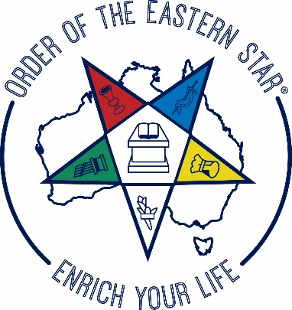 | THE UNITED GRAND CHAPTER OF AUSTRALIA  Order of the Eastern Star  having jurisdiction within the states and territories of Australia and its dependencies
ABN 57 336 115 915  Phone: 03 6263 5605 (home)  Phone from Overseas: + 61 3 6263 5605  Email: wgsecretary@oesaustralia.org.au |  | Worthy Grand Secretary  Mrs Elizabeth Taylor  44 Cobbs Hill Road  LOWER DROMEDARY TAS 7030

10th January 2022

To: Grand Secretaries : District Grand Secretaries : Chapter Secretaries

Dear Sisters and Brothers

MAJOR RAFFLE - EIGHTEENTH SESSION 2022

Once again there will be a major raffle at the 2022 Session of the United Grand Chapter to be held in Sydney in June.

The cost of tickets is $1.00 each and the prizes will be:
First Prize Open Order $500.00
Second Prize Hand-made ‘Aboriginal Print’ Patchwork Quilt $450.00
Third Prize Silver, Gem Studded, Ladies Watch $250.00
Fourth Prize Mystery Prize $150.00

Enclosed is an Order Form and it would be appreciated if you (or a member appointed by your Chapter) would obtain the names and money of your members who wish to purchase tickets.

Order Form and money should be forwarded to: Mrs Joan Whyte
12 Lacewing Way
LEPPINGTON N.S.W. 2179
to reach her prior to 20th May 2022, or should be delivered to the Major Raffle Desk on Level 1 of Bankstown Sports Event Centre on Thursday 16th June 2022 or Friday 17th June 2022.

Cheques should be made payable to The United Grand Chapter of Australia Order of the Eastern Star Sessions Account. It is imperative that this be written in full on cheques for banking purposes. No abbreviations, please.

Yours sincerely,

Elizabeth Taylor

ELIZABETH TAYLOR PDGM
Worthy Grand Secretary.

